IPL Predictor

Team – 07

* 71762131011 – Bubalan S
* 71762131014 – Deshik S
* 71762131041 – Sai nikhil S

Output:

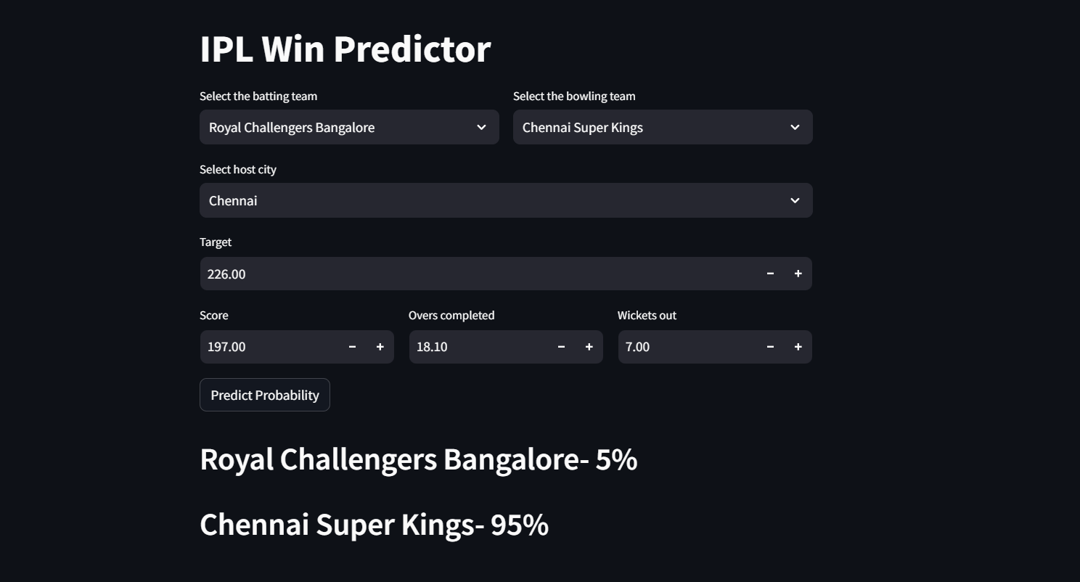

Real World Outcome:

